Manx Shearwaters or the Isle of Rum:

Reconstructing their Past and Forecasting their Future

# Background

The Manx shearwater (*Puffinus puffinus*) population situated in the mountains of Rum (Fig. 1) constitutes approx. a third of the species’ worldwide population. Given proposed offshore wind developments in the north-west region of Scotland’s seas, this population is at potential risk. It is therefore important to develop a baseline for this population, to evaluate risk with as much precision as the currently available data will allow and to produce a population model that allows predictions to be made about how the Rum population may respond to future pressures.

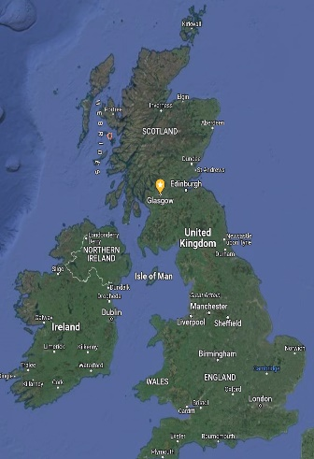

Fig. 1: The manx shearwaters on the isle of rum are an internationally important seabird population whose past and future trajectory was scrutinised by integrated modelling of all available data

This project aimed to apply advanced statistical modelling to all types of relevant available data, including surveys of the Rum population, long term but discontinuous monitoring of burrow occupancy and breeding success in small sample areas, ringing records, weather data and previous studies of rat depredation and rainfall effects. The overarching scientific objective was to construct a robust model of the dynamics and drivers of the Rum shearwater population.

# Integrated population modelling

The key modelling challenge of this study is in distinguishing between true ecological fluctuations and artefacts created by the changes in survey methodology and calculation. The first priority was to develop an *integrative model* that could accommodate all of the available demographic data (on survival and fecundity), have capacity to evaluate multiple covariates of change and be supported by expert views. We adopted a Bayesian Integrated Population Modelling (IPM) approach. In particular, given the dynamical nature of the questions involved, we used a state-space model, which couples a model for the biological (i.e., generative) process together with a model for the observation (i.e., data-collection) process. Models are not solely informed by data inputs and expert opinions, but also by biological constraints. Here, these originate from the key principles of population dynamics. A key priority of our modelling therefore was to recognise such *mechanistic principles* and use an approach that explicitly incorporates constraints. A further priority was to correctly *address uncertainty* in reconstructed parameters, system states, forecasts and hypothetical scenarios. This required us to tread a fine line between acknowledging uncertainty of different forms at the information-input stage, but without being so agnostic that we end up ignoring basic biological principles and cause the model to fail because of lack of information.

# Conclusions

1. The available population and demographic data are sufficient to statistically parameterise an informative population model, which can reconstruct past trends (Fig. 2) and provide informative predictions over periods of decades.

2. It is less clear whether the available data can inform us about the current strength of density dependence and potential consequences for recruitment.

3. It is equally not clear whether the model can detect trends in response to covariates. In the case of the one covariate (rainfall) for which data and prior knowledge existed to do this, the results were not conclusive, and this was confirmed with simulation trials.

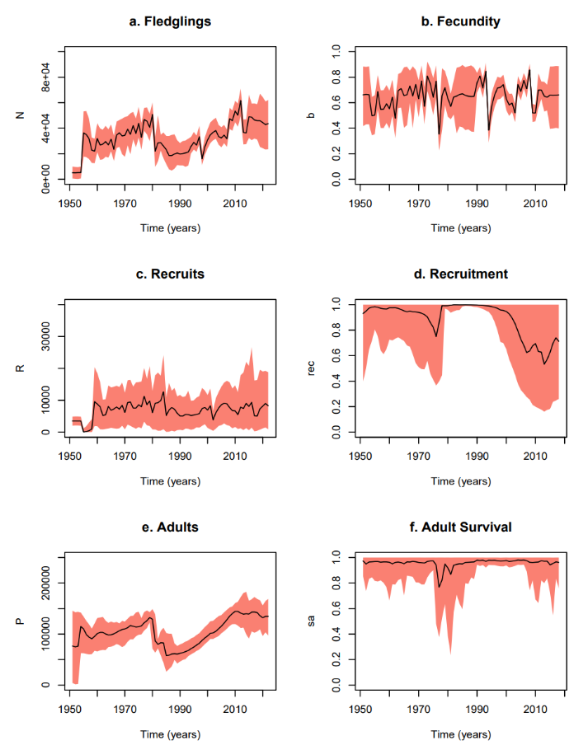

Reconstruction of population trajectories and demographic processes from the state-space model.

4. Investigation of the sensitivity on to population estimates indicates that any additional data collection effort may be better spent in accurately mapping the shearwater greens, rather than increasing effort within well studied areas.

6. Low and intermediate population estimates for 2022 give similar results, indicating a robust family of models.

7. While the survey methods remain unstandardised, the pre-cautionary modelling approach is to proceed with a model that permits both over- and under-estimation of the current population.

8. Predictions from the fitted model anticipate a mostly stable population under the status-quo.

9. Press perturbations seem to be capable of turning the population to a declining trend. For example, a 5% annual reduction in adult survival leads to a 69% chance of decline over the next 25 and 100 years, whereas a more drastic (50%) annual reduction in fecundity would be required for a similar outcome.

10. Subsequently, from these indicative investigations, we conclude that the population would be most vulnerable to long-term but modest reductions in the survival of breeders.